**Lab 6 - Exploitation of a system**

Objectives

* Become familiar with the Metasploit Framework.
* Utilize a pre-made exploit and payload to break into a computer system.

Pre-Lab

For this lab, you'll need your Windows XP and Kali VMs. Be sure both VMs are on the same network, and take note of their IP addresses.

1. Metasploit Framework

* In Kali, open a terminal and launch Metasploit by typing "msfconsole"
* Once loaded, use ms08_067_netapi with a reverse meterpreter shell on the Windows XP Victim PC

Ans: 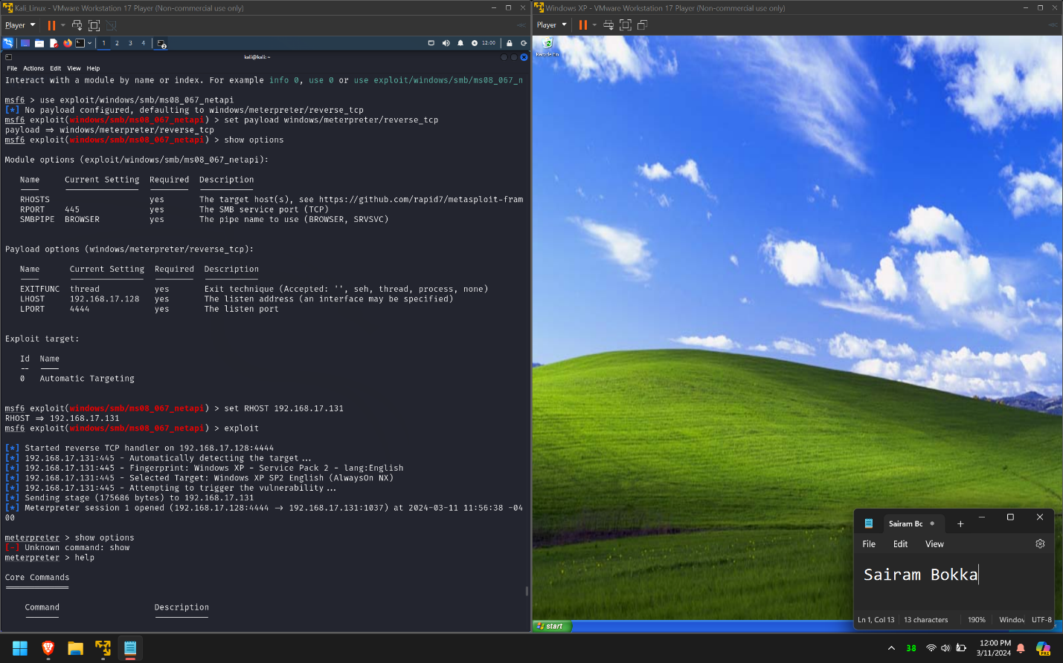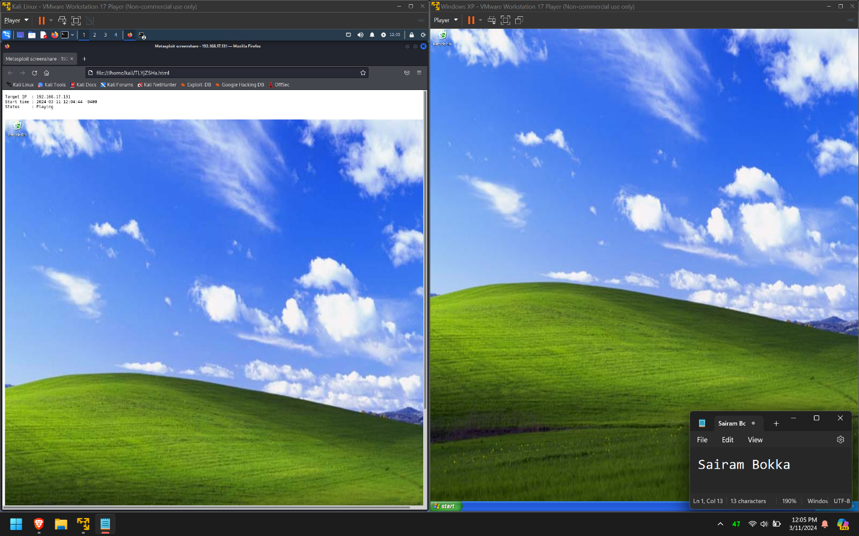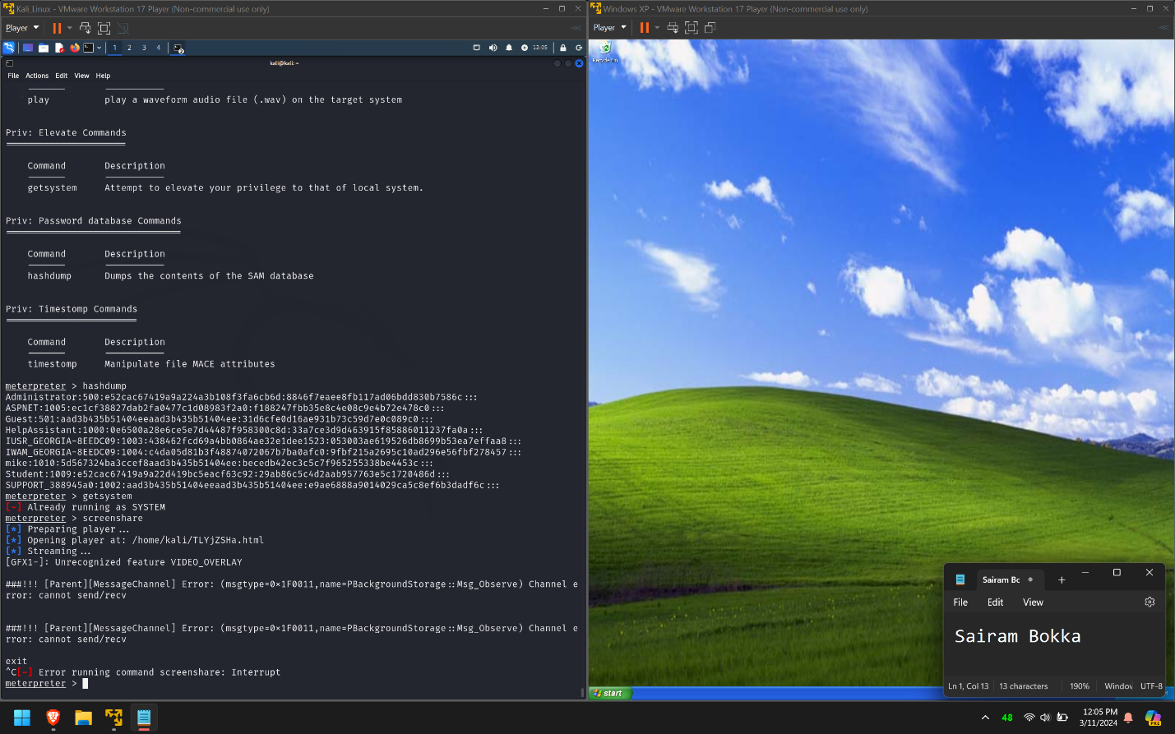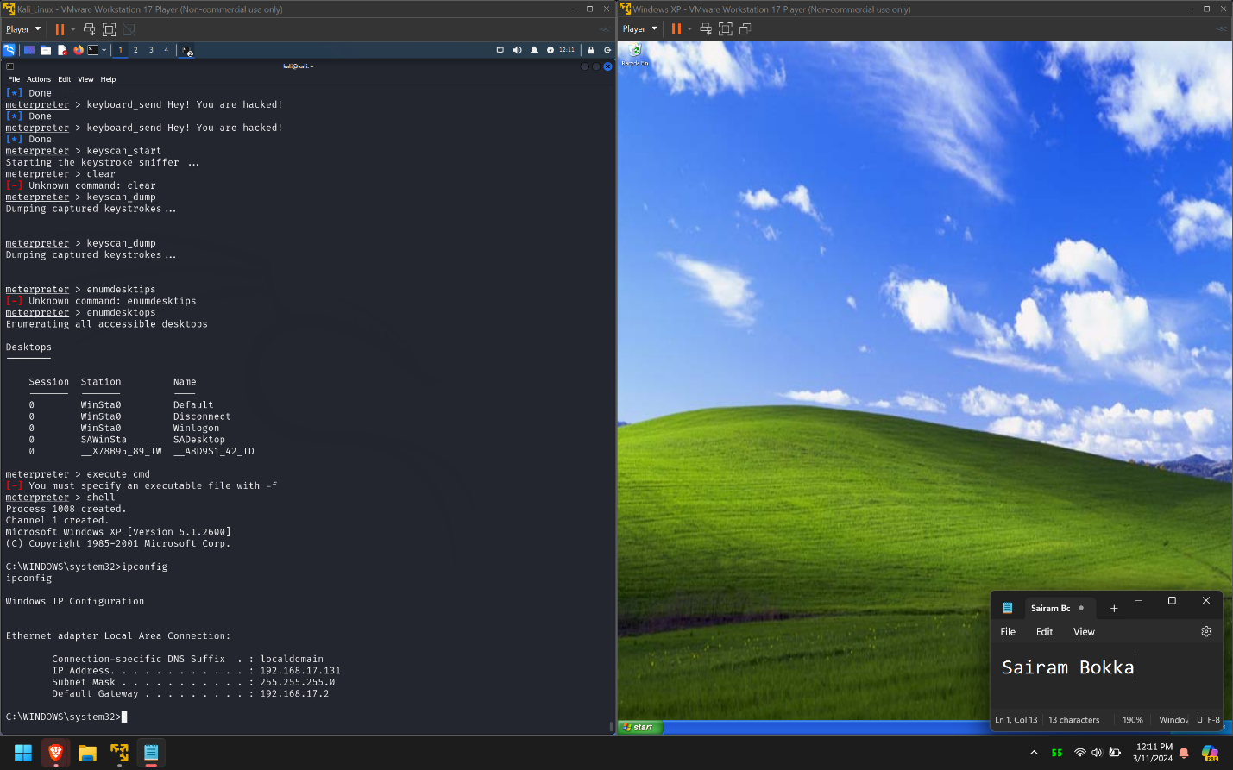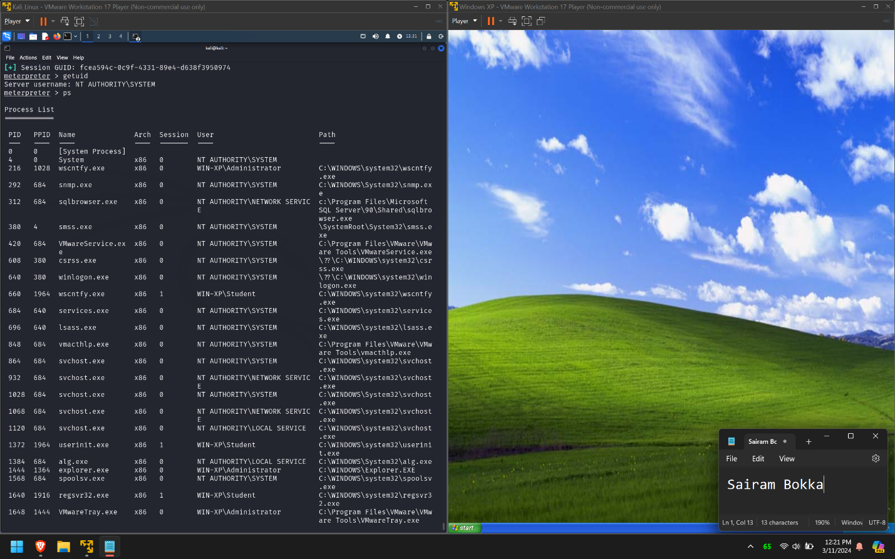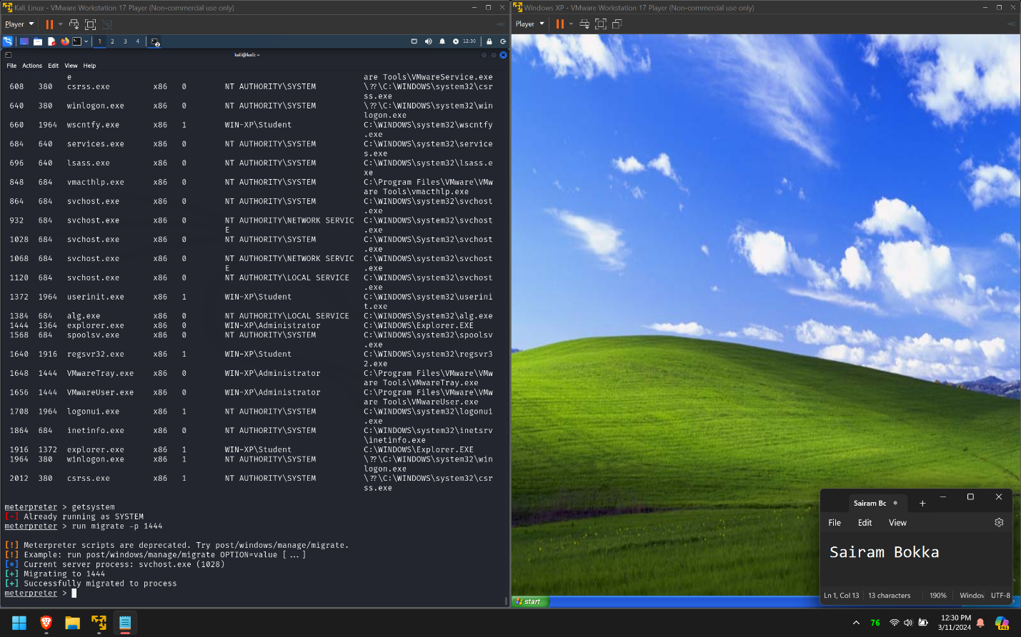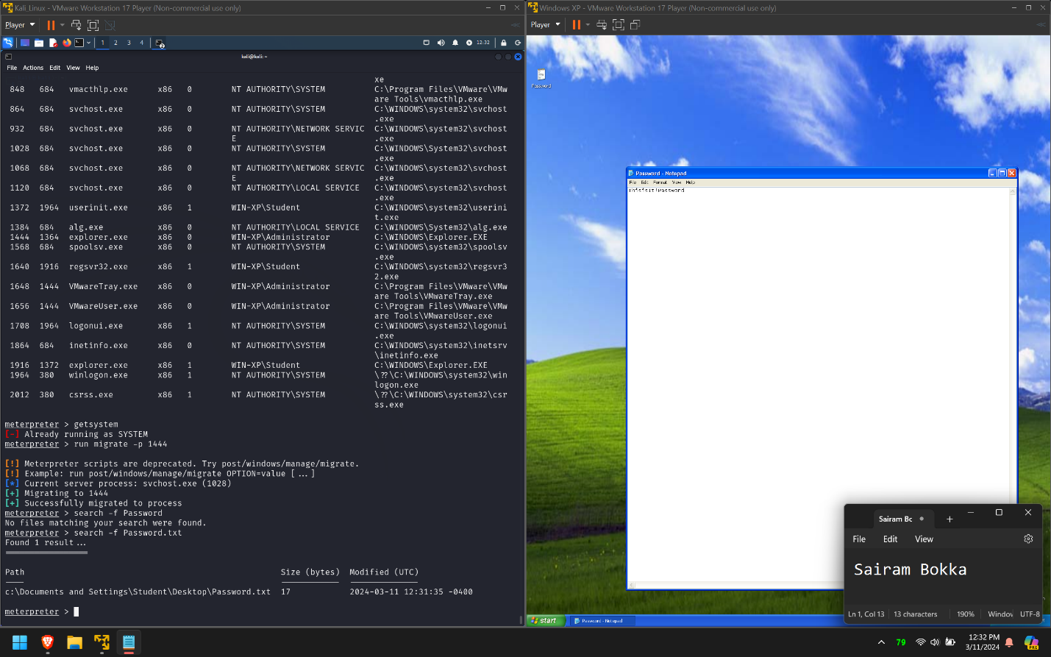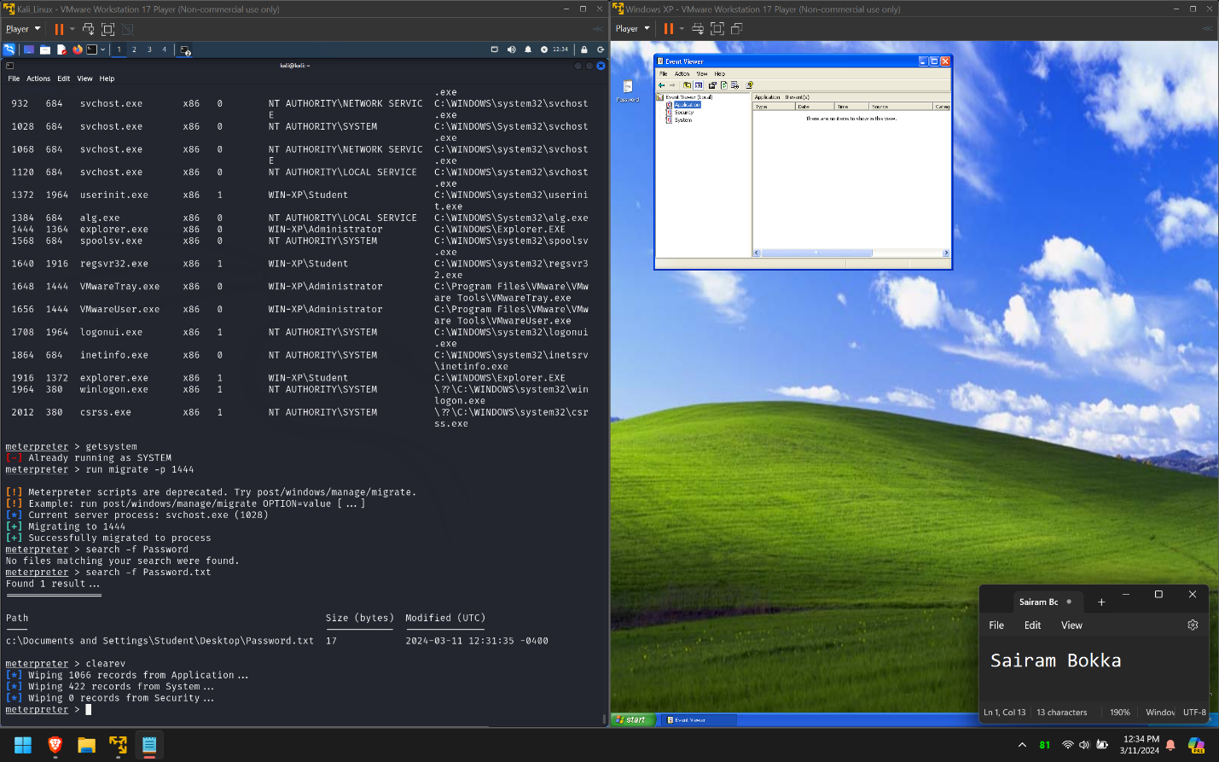

* Successfully exploited windows XP system using MS08_067 exploit for windows XP. After access to the system using meterpreter, used various inbuilt commands like getsystem, ps, shell, screenshare, etc to get more information.
* Also used migrate to migrate to another process to hide meterpreter.
* Finally cleared logs using clearev command to hide tracks.

1. Armitage

* In Kali, open Armitage by clicking on it's icon on the toolbar, or type "armitage" in a terminal.
* When you see the "connect..." Pop Up Window, do not change anything and simply click the "Connect" button. You will then receive a prompt asking to start the Metasploit RPC Server. Select the 'Yes" button.

Ans: 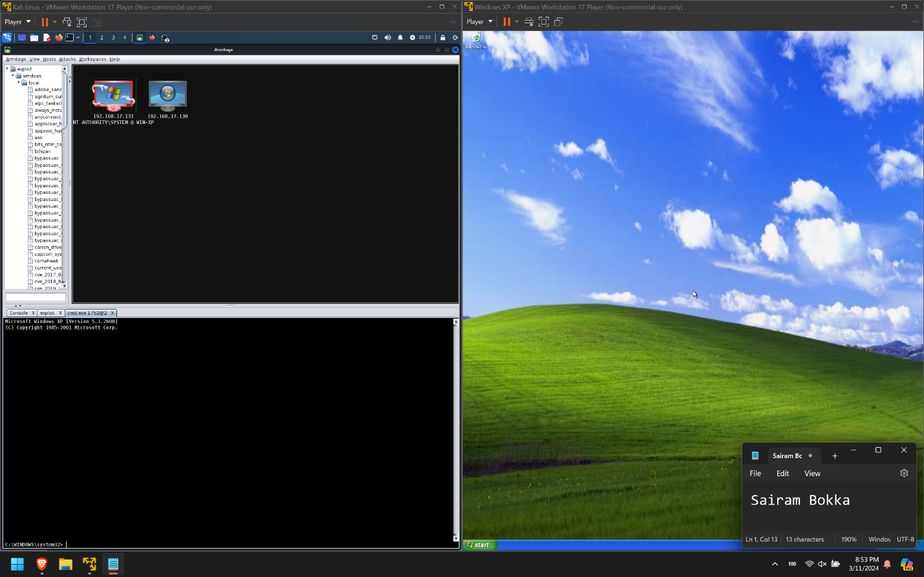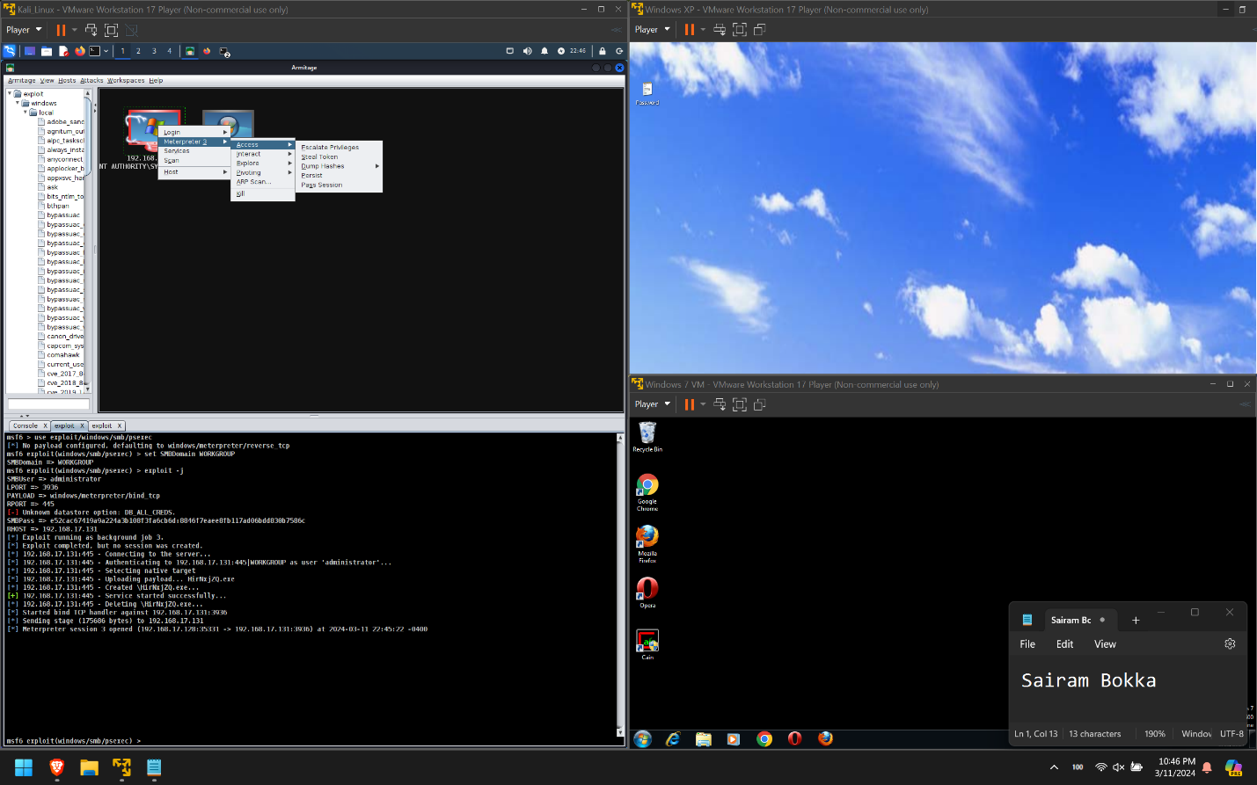

Exploited Windows XP system using Armitage. Got similar results as command line tools.

1. **Optional - Attack your Windows 7 VM**
2. Using Metasploit, find a different vulnerability that can be used against Windows 7. If you used Nessus earlier to scan it, your clue may be found in the Nessus report.

Ans: 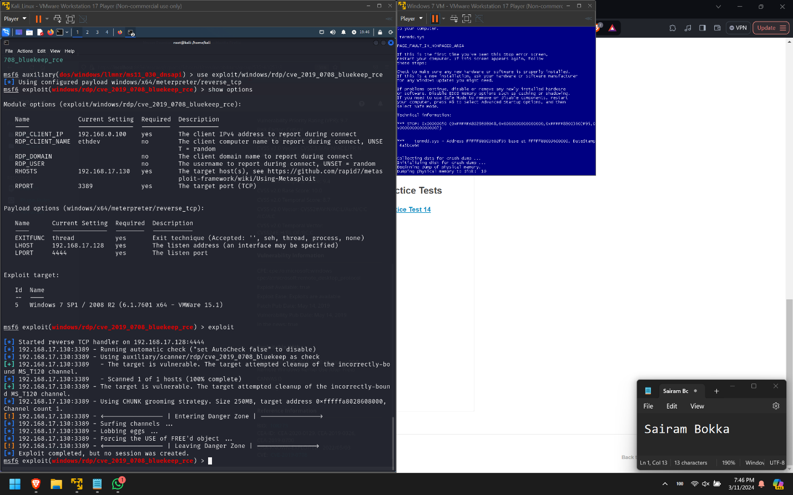

Tried all vulnerabilities from the nessus report. Here is an overview of what happened:

* Bluekeep exploit was crashing the windows 7 system
* Doublepulsar vulnerability was discovered but the exploit was saying that the vulnerability was patched in the system.
* One thing I observed was that, remote desktop had no authentication and anyone could join the session.

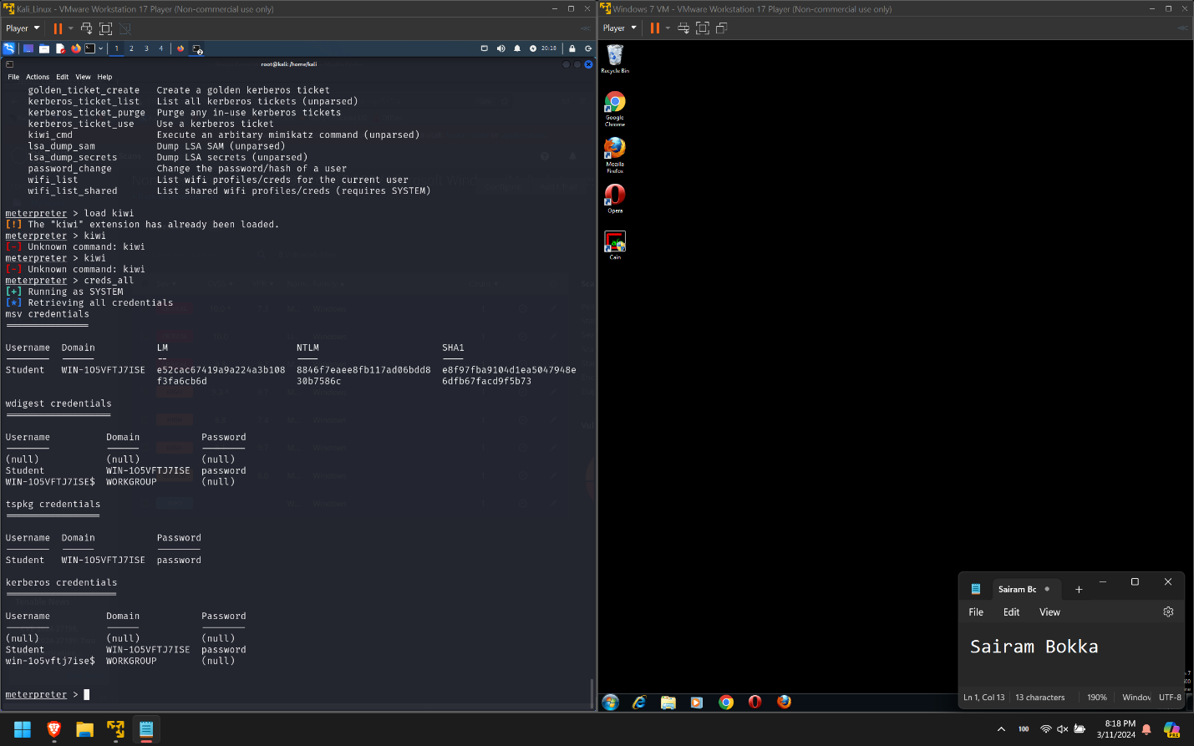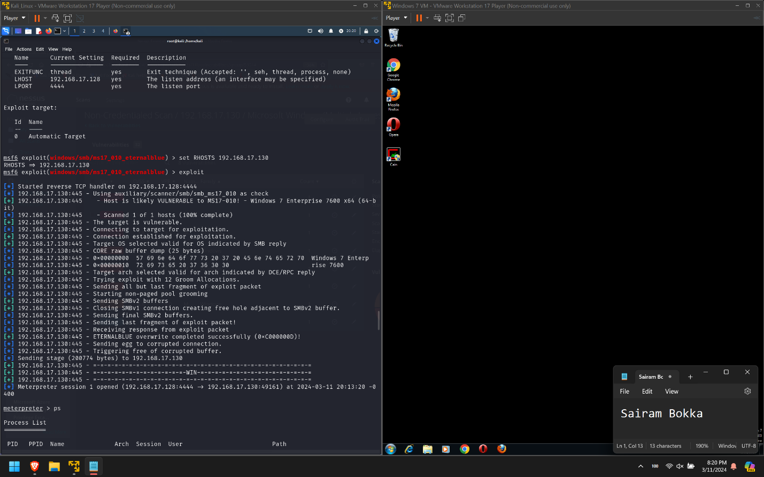

* Finally exploited the system using eternalblue exploit.
* Meterpreter session was established and now system was hacked.
* I used kiwi extension to get all the passwords of the system in plain text as shown in screenshots.